一、辨識句意：每題均有三張圖片，請依據所聽到的句子，選出符合描述的圖片。(每題1分，共15分)
彰化縣立埔心國民中學 106學年度 第二學期三年級第二次段考 年 班 座號： 姓名：
1. ( )
(A)  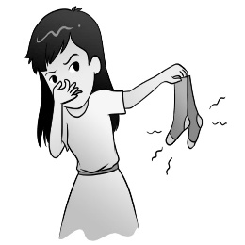 |  | (B)  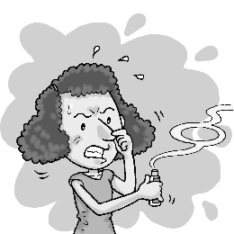 |  | (C)  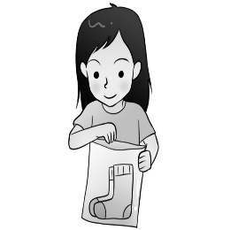
2. ( )
(A)  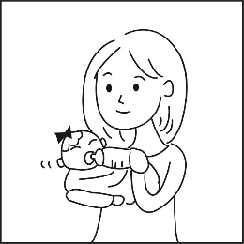 |  | (B)  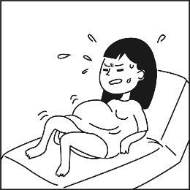 |  | (C)
3. ( )
(A)  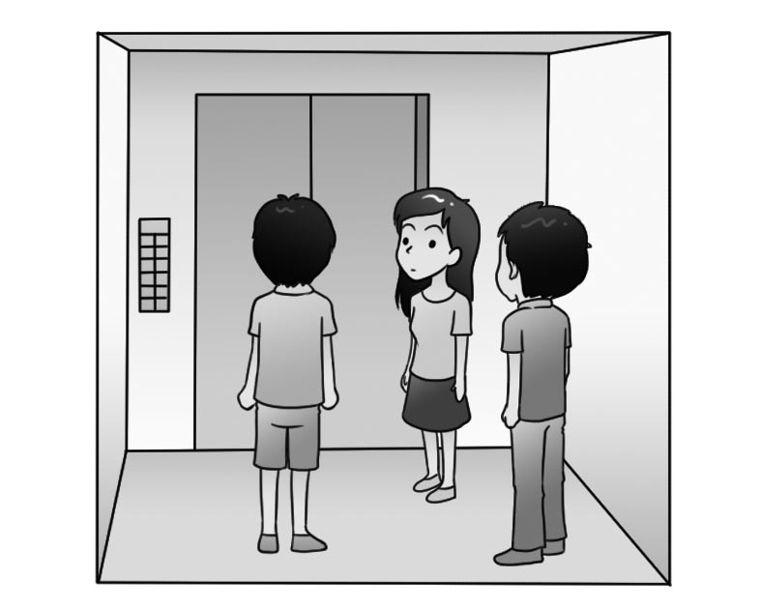 |  | (B)  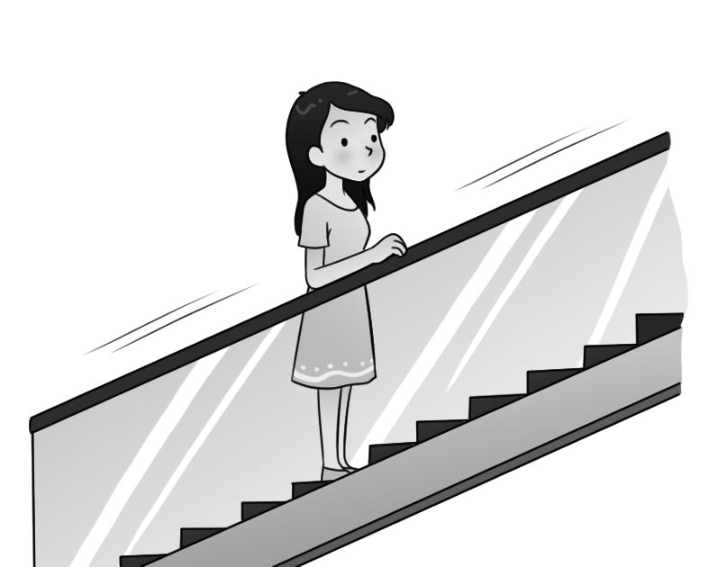 |  | (C)  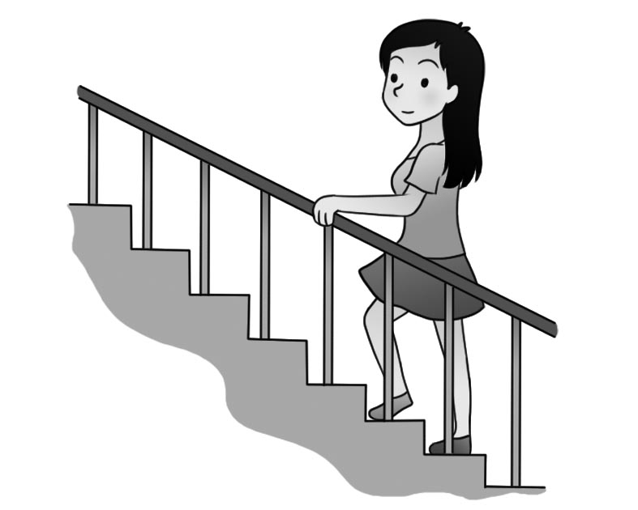
4. ( )
(A)  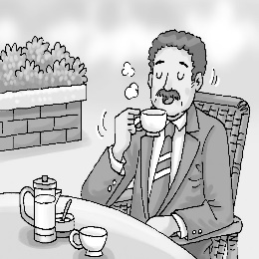 |  | (B)  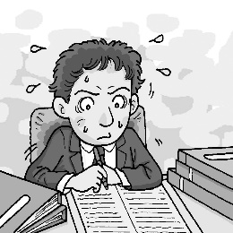 |  | (C)  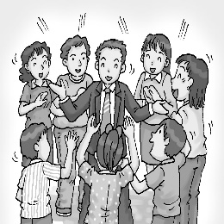
5. ( )
(A)  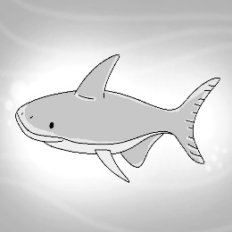 |  | (B)  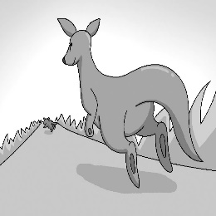 |  | (C)  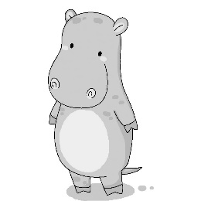

二、基本問答：每題均有三個選項，請依據所聽到的內容，選出一個最適合的回應。
1. ( ) (A) It’s slender.
(B) It’s unbelievable.
(C) It’s endangered.
2. ( ) (A) It went well. I got the job!
(B) It went well. I felt so stressed and didn’t say a word.
(C) It went well. I had a fight with the boss.

3. ( ) (A) That’s because no one places an order.
(B) That’s because there are too many of them.
(C) That’s because the product is very popular.
4. ( ) (A) So, you can’t surf the Net with the
computer, can you?
(B) So, you can’t use the computer, can you?
(C) So, you can’t borrow the computer, can you?
5. ( ) (A) Yes, it feeds on grass.
(B) Yes, it has drawn thousands of people each year.
(C) Yes, it’s covered in mud.

三、言談理解：每題均有三個選項，請依據所聽到的對話
與問題，選出一個最適當的答案。
1. ( ) (A) He’s making pumpkin soup.
(B) He’s making a lantern.
(C) He’s making a cake.
2. ( ) (A) He hates his job.
(B) He has come of age.
(C) His life is rough.
3. ( ) (A) She feels stressed.
(B) She has a fight with the man.
(C) She seems surprised.
4. ( ) (A) They’re going hunting.
(B) They’re climbers.
(C) They’re going to stay a night at a hotel.
5. ( ) (A) He’s a national university student.
(B) He passed away last year.
(C) He has got through the most difficult time
of his life.

四、文意字彙。(每題2分，共20分)
1. Cathy will go hiking with her family tomorrow.
She put a lot of snacks into her __________
(A) basket (B) product
(C) temperature (D) cartoon
2. The number of apples on the table isn’t .
Please count it again.
(A) delicious (B) pretty
(C) correct (D) national
3. It is for nurses to work in the children’s hospital .
(A) beautiful (B) endangered
(C) stressful (D) slender
4. Jason is a . He has studied science since
he was 17 years old.
(A) scientist (B) cook (C) clerk (D) driver
5. Children can’t play in the water alone
their parents are by their side.
- because (B) so (C) yet (D) unless
6. A is a large gray animal, and it loves to play in the water.
(A) koala (B) hippo (C)eagle (D)cat
7. It’s healthier for you to take the stairs than the
.
(A) floor (B) elevator (C) leader (D) odor
8. Joyce is going to have a job later.
(A) bear (B) cook (C) store (D) interview
9. The in Taiwan in summer is so high.
(A) temperature (B) mountain
(C) building (D) baker
10 Mary had a time when she started her
own business.
(A) rough (B) enjoy (C) quick (D)slender

五、語法測驗。(每題2分，共20分)
( A ) 1. The chair my father is sitting is very expensive.
- on which (B)on that (C) which (D) x
( B ) 2. The skirt I bought in Japan was made in Taiwan.
- what (B) where (C) when (D) x
( C ) 3. John didn’t know who opened his gift. When he
got home, it .
(A) will be open (B) has been open
(C) had been open (D) is open
( D ) 4. Tina’s husband is very good at cooking. She
him cook breakfast for her every morning.
(A) asks (B) want (C) tells (D) has
( B ) 5. Harry Potter is the most interesting story
(A)which I have ever read
(B) that I have ever read
(C) which I have never read
(D) that I have never read
( C ) 6. Mrs. Wu is 62 years old, and she has two . (A) child (B) childs (C) children (D) childrens
( D ) 7. The man and his dog take a walk in the park every evening look happy.
(A) who (B) which (C) x (D) that
( B ) 8. is right today may be wrong tomorrow .
(A)It (B) That (C) This (D) What
( C ) 9. Teacher Candy saw Jessica asleep in class, she made her stand for 5 minutes.
(A) falls; but (B) falling; if
(C) fall; so (D) fell; or
( D ) 10. Do you remember ?
(A) where does Helen live
(B) how old is he
(C) when he will come
(D) what should you say

六、完成句子與對話。(每題3分，共15分)
( B ) 1. A: You’re leaving for the Tokyo tomorrow. I feel sad.
B: Don’t be sad.
(A) Saying goodbye is easy to me.
(B) We can still stay in touch. It’s a deal.
(C) Time has already changed us a lot.
(D) I can’t believe you’re leaving me next month.
( D ) 2. A: Have you read the yearbook?
B: Yes, I have. I’m starting to miss you.
(A) I guess the book must be very heavy.
(B) I wondered if you had given it back to me.
(C) This is the most boring book that I’ve ever read.
(D) Many memories came back to me after I read it.
( C ) 3. A: What’s this? What can you do with it?
B: It’s a special marker.
(A) The chance for us to see it is small.
(B) I think your idea about the watch is wild.
(C) With it, I can write words that others can’t read.
(D) It’s a good time to buy the marker at a low price.
( C ) 4. My family doctor told me that I was too thin.
(A) That’s why my dream won’t come true.
(B) I was asked to eat less and stay on the bed.
(C) She wants me to eat more before it’s too late.
(D) It has been a difficult choice for me all the time.
( A ) 5. A: Wow. Your T-shirt looks cool!
B: Thanks, and it has many functions, too. For
example, .
(A) it can raise my body temperature
(B) it’s hard to control my body odor
(C) I got to buy it because of your help
(D) I’ve learned to respect others because of it

七、克漏字測驗。(每題3分，共15分)
Dear Mr. Wreth,
You are the best teacher I’ve ever met! Thank you for
1. such a great teacher. Every day you come to school
with a big smile on your face. In your class, you taught us
countries in the world by 2. maps. You made each of us
3. eager to learn. 4. you, I have learned a lot about
the world. Now I know that the longest river is the Nile, and
the highest mountain is Mt. Everest. I would like to know more about the world.
5. I’ll send you postcards from the countries I visit.
Best regards,
Dunn eager 渴望的
( A ) 1. (A) being (B) be (C) is (D) have been
( A ) 2. (A) using (B) use (C) being used (D) used
( B ) 3. (A) feels (B) feel (C) felt (D) feeling
( D ) 4. (A) Until (B) No longer
(C) Because (D) Because of
( C ) 5. (A) It’s true that it’s a small world.
(B) I’d like to become a cook in the future.
(C) One day, I hope to travel around the world.
(D) If I run low on food, I’ll place an order online.
八、閱讀測驗。(每題3分，共15分）
【A】
Formosan Black Bear |  | Panda
200-600 | Population | 2,000
Taiwan | Native place | China
1,000-3,000 | Area (meters) | 1,200-4,100
130-160 | Hight (cm) | 120-180
100-200 | Weight (kg) | 85-150
V-shapes on their chests | Features | Ears, the nose, legs, the back are black, while the other parts are white.
Small animals, insects, and fruit | Food | 99% bamboo
population 總數 native place 原住地 weight 重量
while 然而 bamboo 竹子
( D ) 1. How many pandas are there in the wild?
(A) 200. (B) 600. (C) 800. (D) 2,000.
( C ) 2. Where can a Formosan Black Bear be found?
(A) In China’s mountains.
(B) In China’s plains. plain 平原
(C) In Taiwan’s mountains.
(D) In Taiwan’s plains.
( A ) 3. Which is true?
(A) Formosan Black Bears are heavier than pandas.
(B) Formosan Black Bears are taller than pandas.
(C) Formosan Black Bears eat a lot of bamboo.
(D) Pandas have special marks on their backs.
【B】
After a busy day at work, you just want to sit on the sofa, watch TV, and get some rest.
Who can help you clean the house?
The answer is—oRobot!
All you have to do is to turn it on.
It will sweep the floor for you.
It’s so flat that it can go under your bed or sofa easily.
You can use it at night because it is quiet and
makes no noise.
When the power is about to run out,
it will go back to its base.
It costs NT$8,899 now.
--Free shipping before March 31.--
( A ) 4. Which is true about oRobot?
(A) It will sweep the floor before you get home.
(B) It sleeps on the sofa after it cleans the house.
(C) It cost you less than eight thousands to buy
oRobot.
(D) You can’t use oRobot at night because it will
make a lot of noise.
( D ) 5. What does “flat” mean here?
(A) As big as a computer. (B) Very convenient.
(C) Sharp. (D) Not very thick.

答案欄 ____年____班 座號：____姓名：________
- 辨識句意(5%)
1. | 2. | 3. | 4. | 5.
- 基本問答(5%)
1. | 2. | 3. | 4. | 5.
- 言談理解(5%)
1. | 2. | 3. | 4. | 5.
- 文意字彙(20%)
1. | 2. | 3. | 4. | 5.
6. | 7. | 8. | 9. | 10.
- 語法測驗(20%)
1. | 2. | 3. | 4. | 5.
6. | 7. | 8. | 9. | 10.
- 完成句子與對話(15%)
1. | 2. | 3. | 4. | 5.
- 克漏字測驗(15%)
1. | 2. | 3. | 4. | 5.
- 閱讀測驗(15%)
1. | 2. | 3. | 4. | 5.
答案欄 ____年____班 座號：____姓名：________
一 辨識句意(5%)
1.C | 2.B | 3.C | 4.B | 5.C
二 基本問答(5%)
1.B | 2.A | 3.C | 4.A | 5.B
三 言談理解(5%)
1.B | 2.A | 3.C | 4.B | 5.C
四文意字彙(20%)
1.A | 2.C | 3.C | 4.A | 5.D
6.B | 7.B | 8.D | 9.A | 10 A.
五語法測驗(20%)
1.A | 2.D | 3.C | 4.D | 5.B
6.C | 7.D | 8.D | 9.C | 10.C
六 完成句子與對話(15%)
1.B | 2.D | 3.C | 4.C | 5.A
七 克漏字測驗(15%)
1.A | 2.A | 3.B | 4.D | 5.C
八 閱讀測驗(15%)
1.D | 2.C | 3.A | 4.A | 5.D

