彰化縣三條國小108學年度上學期第二次學業定期評量英語領域試卷
class(班級): 五年甲班 Number(座號): _______ Name(姓名): ________________
I. Listen and circle(圈出聽到的圖片)18%
1. ○ | 2.  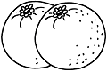   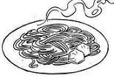○ | 3.○ 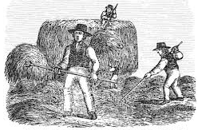
4.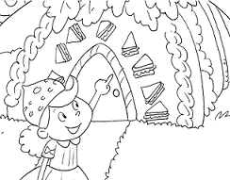 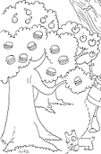○ | 5.○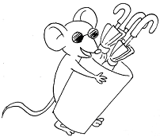 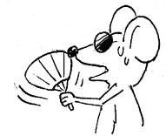 | 6.○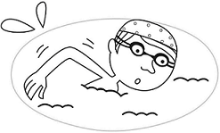 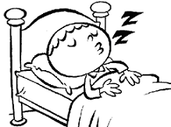
II. Listen and check(勾選適當的回答)10%
□ No, it’s not. It’s cloudy.
☑ No, it’s not. It’s cool.

☑ Thanks a lot.
□ That’s too bad.
- He likes apples.
1.
4
☑ Yes, I do.
☑ It’s windy and cool.
2
□ Is it windy there?
5
☑ Yes, she does.
3
□ Yes, she likes.
III. Listen and circle (圈出聽到的字)12%
1. whale  hale | 2. thin  chin | 3. that  what | 4. then  wham | 5. cheat  wheat | - thin  tin
IV. Read and write (讀一讀，寫出發音組合)5%
1. 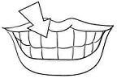 2.  3. 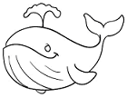 4. 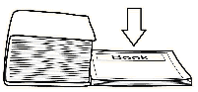 5. 
tee_th_ _wh_ite _wh_ale _th_in _wh_eel
V. Write(單字測驗)12%
- 晴朗的 _sunny_______ 5. 香蕉 _banana________ 9. 溫暖的 _warm________
- 下雨的 _rainy________ 6. 漢堡 _hamburger_____ 10. 蛋 _egg____________
- 陰天的 _cloudy_______ 7. 柳橙 _orange________ 11. cool _涼爽的_________
4. 寒冷的 _cold_________ 8. 麵條 _noodles_______ 12. sandwich _三明治______
VI. Choose(選擇)10%
1. ( A ) __ she like cake? Ⓐ Does Ⓑ Is Ⓒ Do
2. ( C ) A: __ B: No, it’s not. Ⓐ How’s the weather? Ⓑ Can you help us? Ⓒ Is it windy?
3. ( B ) My mother doesn’t __ chocolate. Ⓐ likes Ⓑ like Ⓒ likeing
4. ( B ) A: Does Eva __ apples? B: Yes, she __ apples. Ⓐ likes ; likes Ⓑ like ; likes Ⓒ likes ; like
5. ( C ) I’m home. Ⓐ 我要回家。 Ⓑ 我在家。 Ⓒ 我回來了。
VII. Read and match (請配對與圖片相符的句子) 12%
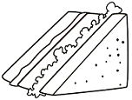  A. | 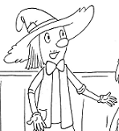  等一下!  B. | C.
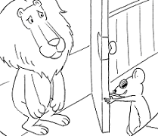  D. | 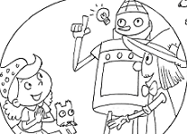  E. | 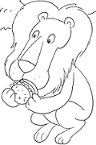  F.
1.( B ) Wait a minute! 4.( F ) He only likes hamburgers.
2.( D ) Welcome back. 5.( C ) Make hay while the sun shines.
3.( E ) I have an idea. 6.( A ) Kim wants a sandwich.

VIII. Answer(句子重組及回答問題) 16%
1. How’s / weather / ? / today / the _How’s the weather today?_
2. want / banana / ? / Do / one / you _Do you want one banana?_
3. milk / . / He / eggs / likes / and _He like milk and eggs._
4. Is it warm today? (依實際回答)_Yes, it is._
5. Do you like sandwiches? (用肯定回答) _Yes, I do._
6. 今天天氣晴朗。(中翻英) _It’s sunny today._
7. 我不喜歡吃蛋。 (中翻英) _I don’t like eggs._
8. An apple a day keeps the doctor away. (英翻中) _一天一蘋果，醫生遠離我。_
IX. Choose (請選出適合的答案) 5%
The weather is nice today. Jay and his
( c )1. ⓐ eats ⓑ eat ⓒ eating
( b )2. ⓐ like ⓑ likes ⓒ want
( c )3. ⓐ isn’t ⓑ don’t ⓒ doesn’t
( c )4. ⓐ Where ⓑ When ⓒ How
( a )5. ⓐ they ⓑ He ⓒ We
family are having a picnic. Jay is 1. a
hamburger. He 2. hamburgers very
much. His sister 3. like hamburgers.
She only likes sandwiches. 4. about
Jay’s parents? Oh, 5. like bananas
and eggs.



I. Listen and circle
- It’s cloudy and cool.
- I like oranges and noodles.
- An apple a day keeps the doctor away.
- Look! A hamburger tree.
- It’s rainy. Take an umbrella when going out.
- It’s a nice weather for swimming.
II. Listen and choose
- Do you like apples, Daniel?
- How’s the weather?
- Does Sally like hot dogs?
- Is it hot?
- It’s cold today. Put on this coat.
III. Listen and circle
- whale
- thin
- what
- then
- cheat
- tin

