彰化縣二林鎮中正國民小學一百零八學年度下學期六年級英語科期中評量
班級: 六年 班 座號: 姓名:
Part Two: Writing Test 書寫測驗 共95分
- Look and Write依據圖片題號順序
寫出空格中的單字 每格2分，共16分

(1) 學校  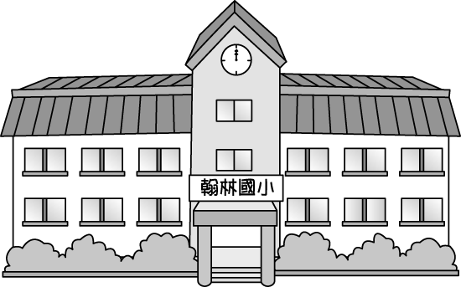 | (2) 家  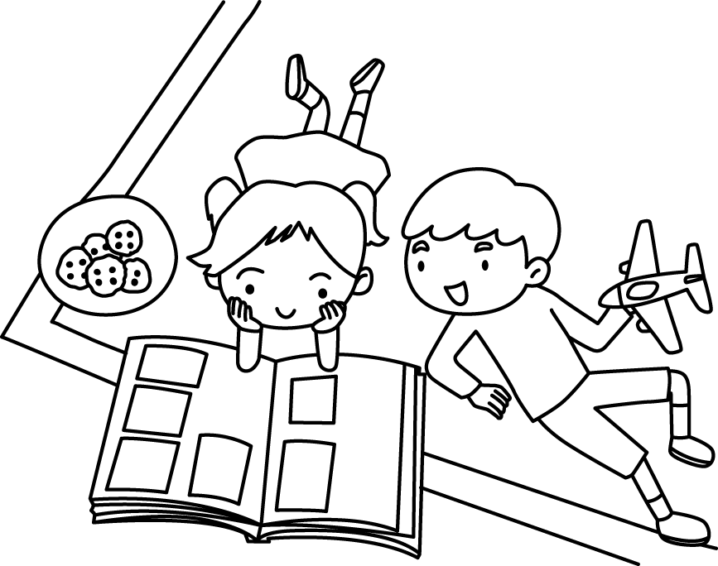 | (3)  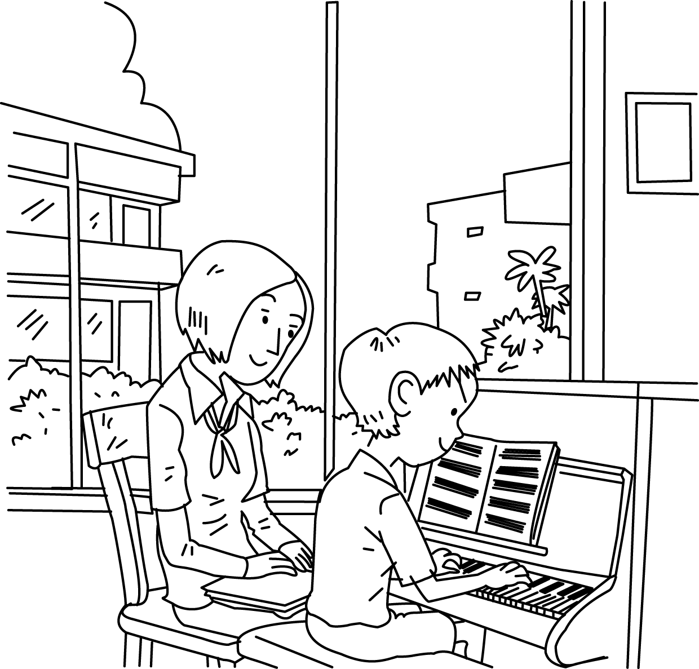 | (4)  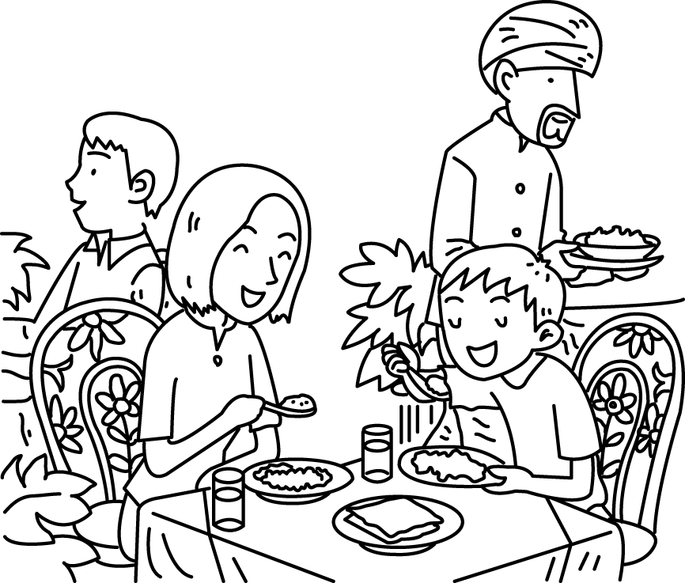
(5)  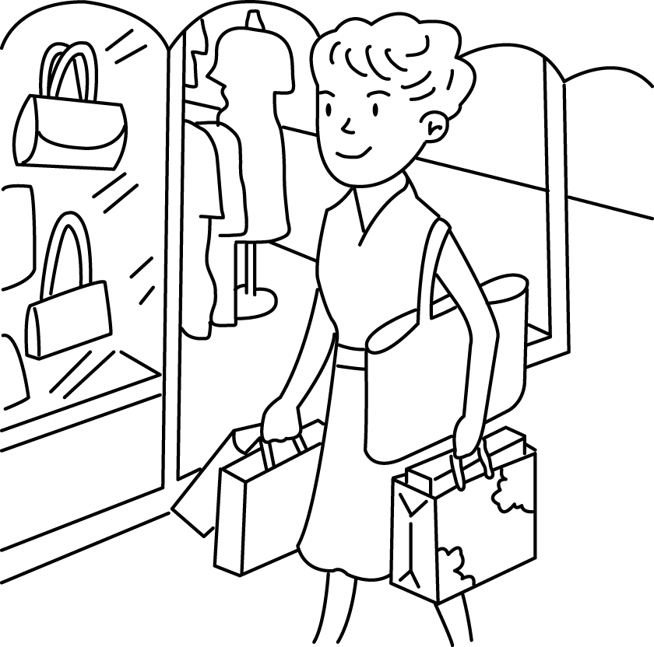 | (6) 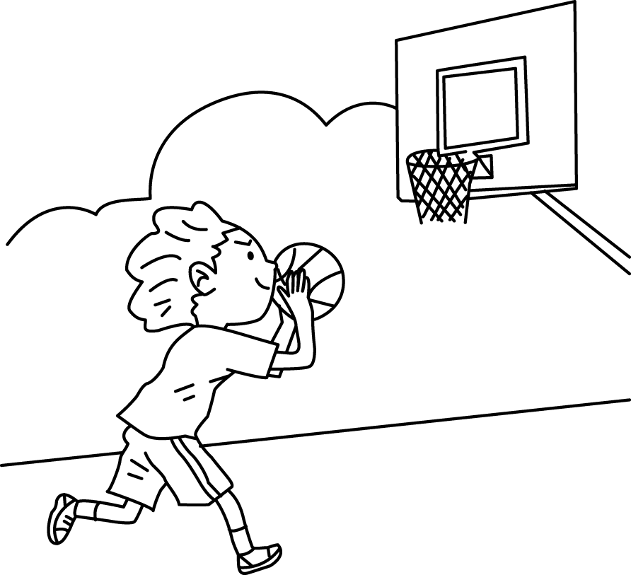 | (7)   | (8)  

1. It was Sunday yesterday. Kim was not at
(1) . She was at (2)
with her sister. They played the (3)
together. It was fun. Then, she had lunch at
the (4) with her friends. She
was at the (5) in the
afternoon. She wanted to buy a gift for her
mom. After that, she went to the park by bus. She played (6) there. At five o’clock, she surfed the (7)
at the library. Before she went to bed at night, she listened to (8) . Yesterday was really a great day!

B. Read and Mark 畫線部分發音相同的單字畫 ○ 不同的打 × 每題1分, 共7分

( ) 1. glasses grass
( ) 2. stone short
( ) 3. black plane
( ) 4. swim sweep
( ) 5. tree toad
( ) 6. skate scooter
( ) 7. drink drive

C. Fill in the Missing r-control words依據圖片提示 寫出下列單字缺漏的複合子音 每格2分, 共12分

(1) (2) (3) (4) 開心的 (5) (6) 黑色
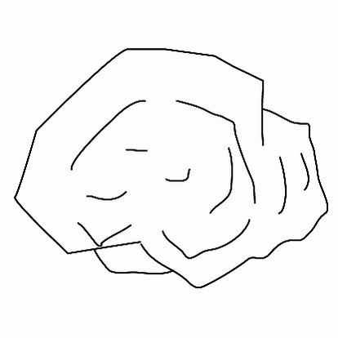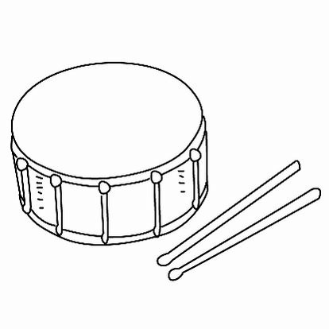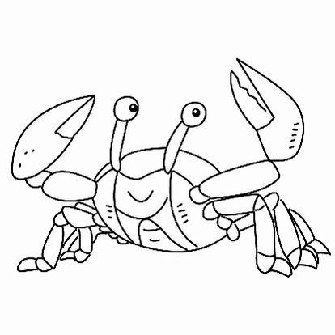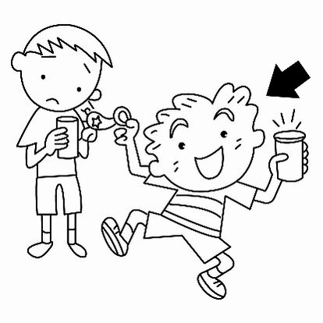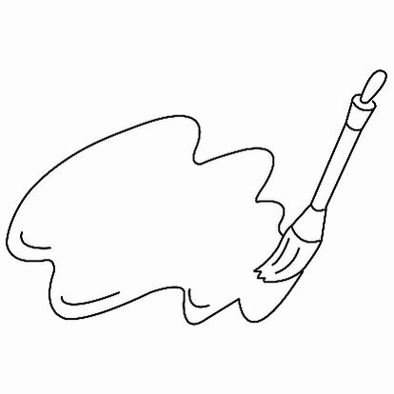
A grasshopper is standing on a (1) one under the tree. He is playing the (2) um and eating some cake with cream. A (3) ab comes and says, “Hi, (4) ad to meet you! Do you want some (5) eets?” The grasshopper says, “No, thanks. I’m so thirsty. I want some (6) ack tea now.”

D. Multiple Choice 選擇 每題2分, 共12分

( ) 1. A:What you do yesterday?
B: I the violin yesterday.
(1) do; played (2) did; played
(3) did;play
( ) 2. A: Did he his grandma last Sunday?
B: Yes, he did. He his grandma last Sunday.
- visited; visit (2) visit; visits
(3) visit; visited
( ) 3. A: Were you at home yesterday morning?
B: Yes, I .
(1) was (2) am (3) were
( ) 4. A: What did Amy do last night?
B: .

(1) She was at the movie theater.
(2) She did her homework.
(3) She is riding a bike.
( ) 5. A: Did John and Kevin play baseball
last weekend?
B: Yes, they .
(1) were (2) do (3) did
( ) 6. My sister at the zoo now.
(1) is (2) was (3) were

E. Rearrange the Words to form Proper Sentences 句子重組 每題 4 分 共 20 分

1. / did / they / What / ? / night / do / last /

2. go / the / Let’s / . / now / theater / to /

3. was / Russia / Danny / . / Monday / in / last /

4. / be / your / She / . / can / sister /

5. / weren’t / at / yesterday /. / the / We / park /

F. Fill in the Blanks 文意填空 (從選項裡選) 每格2 分，共 10 分

did / score / with / were / at
Susan: I didn’t see you at the library yesterday. Where you?
Tom: I was school.
Susan: What you do there?
Tom: I played basketball my
classmates.There was a basketball game.
Susan: How was the game?
Tom: It was exciting. The was 73 to 72. We won (獲勝) the game!
G. Look and Match 上下句子配對 (寫小寫字母代號) 每題 2 分, 共 8 分

( ) 1. A: You danced so well. This is for you.
B:

( ) 2. A: What’s wrong? You looked tired.
B:
( ) 3. A:
B: I was at the ballet theater. And I danced.
( ) 4. A:
B: Yes, I did. I danced Flamenco.

a. Did you dance in Spain?
b. It’s a long story.
c. Where were you yesterday?
d. It’s beautiful. Thank you.

H. Reading Comprehension 閱讀理解 根據對話 正確的答案畫 ○ 不正確的答案打 ×
每題 2分, 共10分

Sam: It was rainy yesterday. Were you at home all day?
Jack: No, I wasn’t. I was at the hospital.
Sam: At the hospital?
Jack: Yes, I was sick, but I’m OK now.
Sam: I see. By the way, do you want to go to the movie theater with me this afternoon? The new movie “Henry Potter” is playing.
Jack: Sorry, Sam. I can’t go with you. I have to do my homework at home.
Sam: Oh, poor you!
＊by the way 順帶一提 play 上映
( ) 1. The weather was good yesterday.
( ) 2. Jack was at the hospital yesterday.
( ) 3. Jack is not sick, he is OK now.
( ) 4. Jack and Sam want to go to the movie theater together this afternoon.
( ) 5. Jack wants to do his homework at home this afternoon. He cannot go to the movie theater with Sam.

Answer sheet
A
- school (2) home (3) piano (4) restaurant
(5) mall (6) basketball (7) Internet (8) music

B
1. (x)
2. (x)
3. (x)
(4) (o)
5. (x)
6. (o)
7. (o)

C
- stone
- drum
- crab
- glad
- sweet
- black

D
- (2)
- (3)
- (1)
- (2)
- (3)
- (1)

E
- What did they do last night?
- Let’s go to the theater now.
- Danny was in RUSSIA LAST Sunday.
- She can be your sister.
- We weren’t at the park yesterday.

F
were/ at / did / with / score

G
1. (d)
2. (b)
3. (c)
4. (a)

H
  - (x)
  - (o)
  - (o)
  - (x)
  - (o)

